Homemade Christmas Cakes
Made To Order

Chocolate Yule Logs £15
(Milk/Dark Chocolate Options Available)
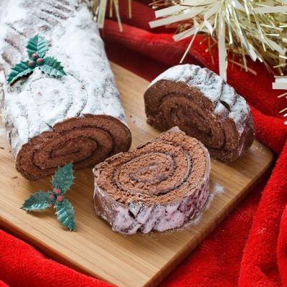
Royal Icing/Fondant Icing Christmas Cakes
With/Without Marzipan & With/Without Nuts
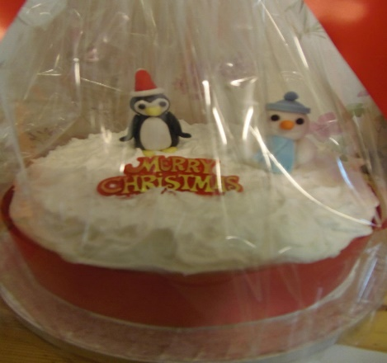
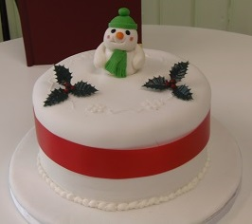

6 Inch – £30, 8 Inch - £40, 10 Inch - £50
Christmas Puddings - £14
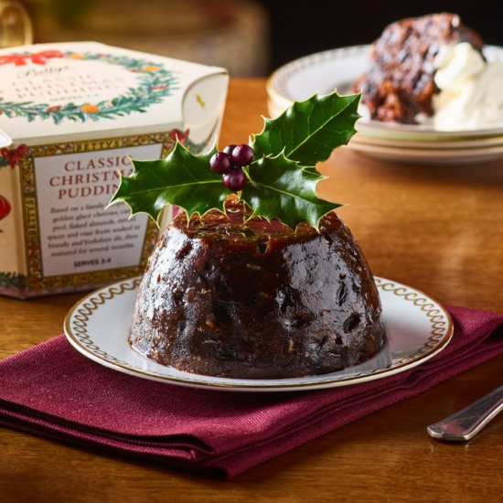

Mince Pies
6 for £4.75, 12 for £9.30, 18 for £13.50

Order Forms Available
at the Counter

