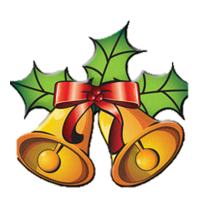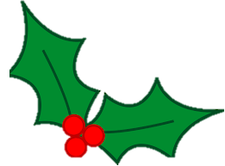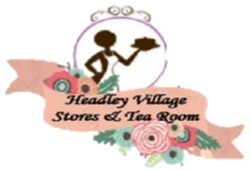HEADLEY FESTIVE

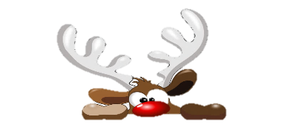**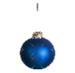AFTERNOON TEA

**Afternoon Tea is a Special Treat, and what better time to treat yourself and your Friends/Family than at Christmas? So, we are offering a Special Festive Twist on Afternoon Tea to help you get into the Festive Spirit!**

**This Yule Tide Treat could include:**

**Variety of Sandwiches**

**Complimentary Pig In Blanket.**

**With Yule Log Slice, Mince Pie and Scone to Follow**

**A Proper Festive Feast!!**

**£19.95 with Bottomless Pots of Tea/Coffee**

**£23.90 pp With a Glass of Mulled Wine**

**£26.90pp With a Glass of Prosecco**

BOOK YOUR TABLE TODAY

RESERVATION ONLY

Starting 21st November

