READY FOR COLLECTION

PRE ORDER NOW….

your

Christmas & New Year

Juicy Fruity

Please Ask for Details

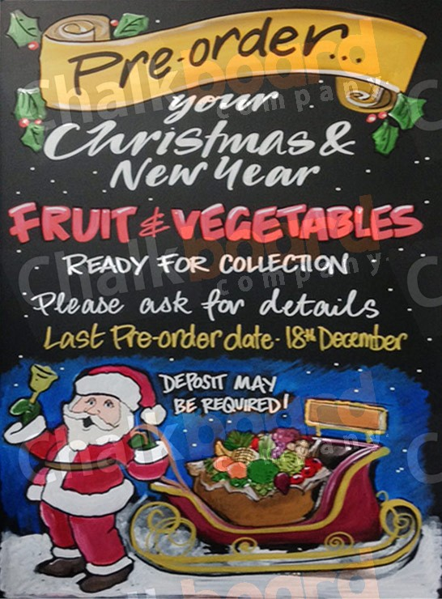**Last Pre-Order: Thurs 17th Dec**